Monthly Report – MediFor Project

Ashish Gupta

April 6, 2018

An important deadline we are aiming for is the mid-may ‘GAN challenge’ for TA1 teams. In view of their subject matter importance, generation of fake facial images and/or facial attributes is a priority. Subsequently, we will extend GAN training to generic visual class. There are two main parts to our work-flow: extracting and pasting faces from donor to recipient image; and evaluating different GAN variants for faces.

### Face Swap

Donor→Recipient face pasting is also popularly called face-swap. We are looking at using both GANs and ‘conventional’ methods of doing this task. The block diagram below are the key step

Donor Image

Modify ambient illumination

Warp donor face image patch

Segment face

Extract facial Landmarks

Recipient Image

We are following the work in Yuval Nirkin, Iacopo Masi, Anh Tuan Tran, Tal Hassner, Gerard Medioni, "On Face Segmentation, Face Swapping, and Face Perception", IEEE Conference on Automatic Face and Gesture Recognition (FG), Xi'an, China on May 2018.

I used this work as guideline for some early results on face pasting. The results and caveats are listed below.

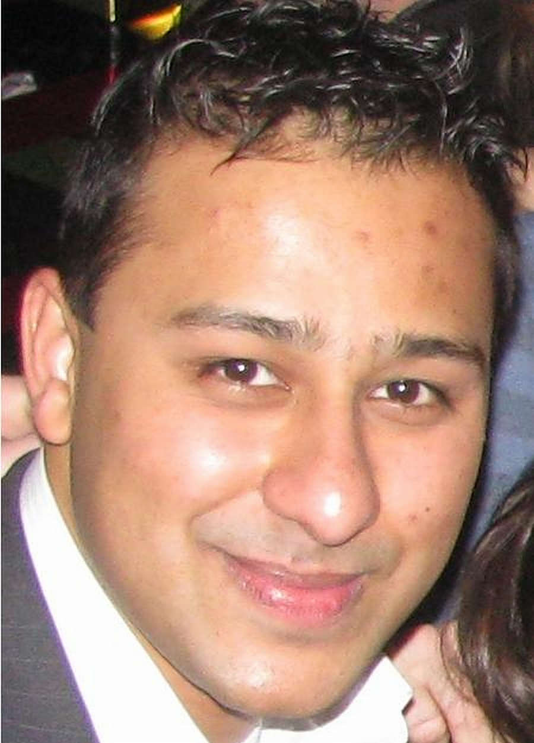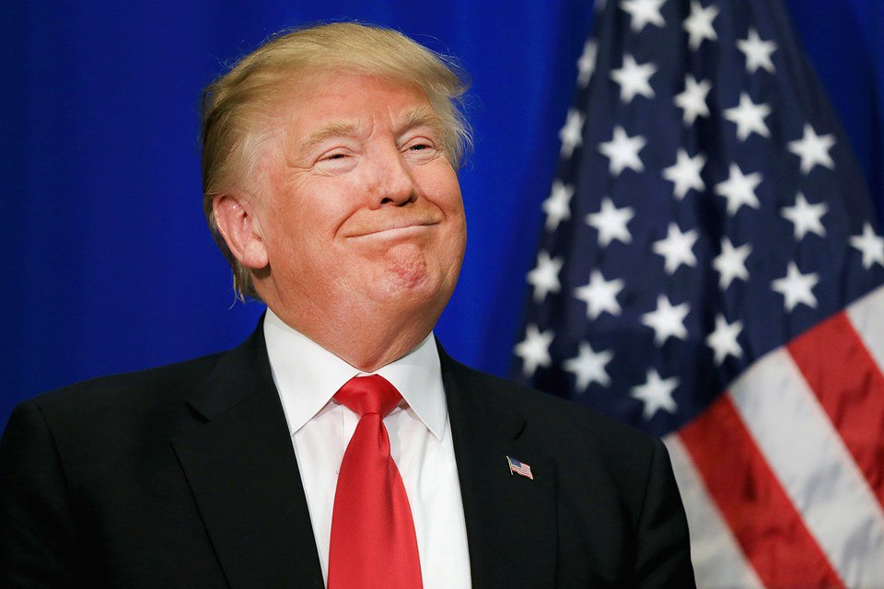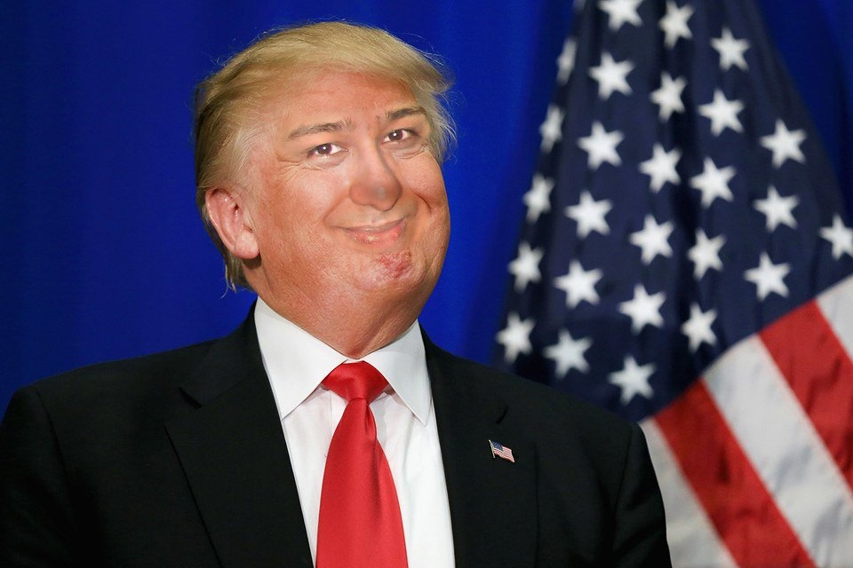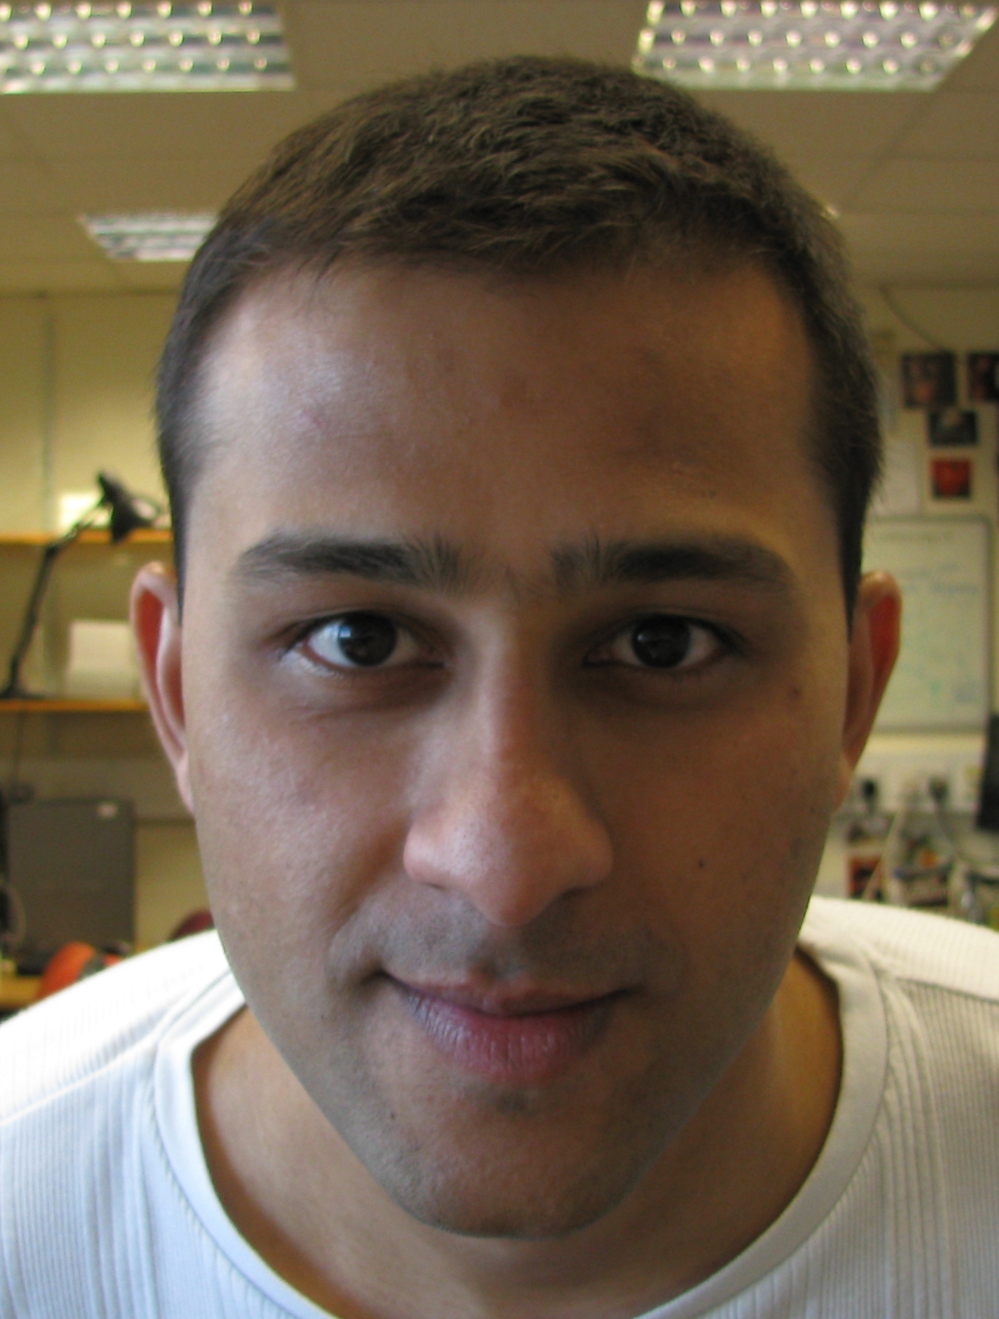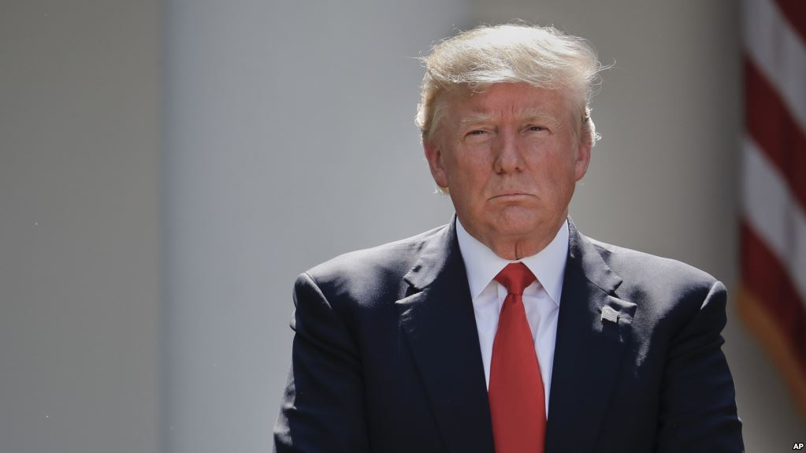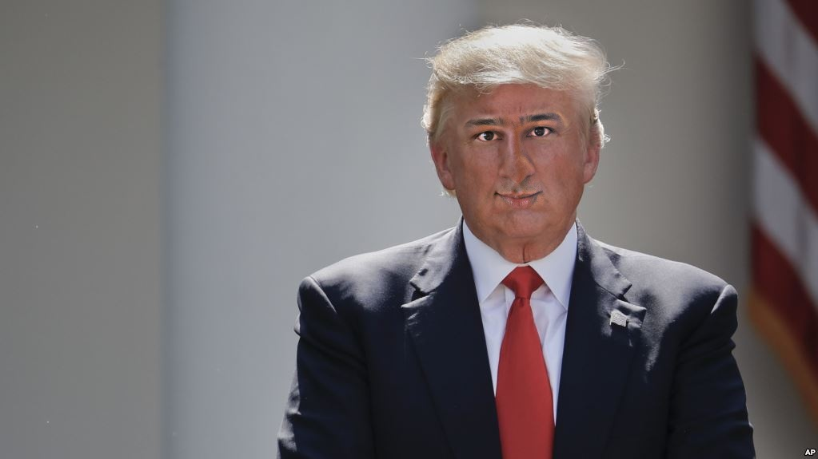

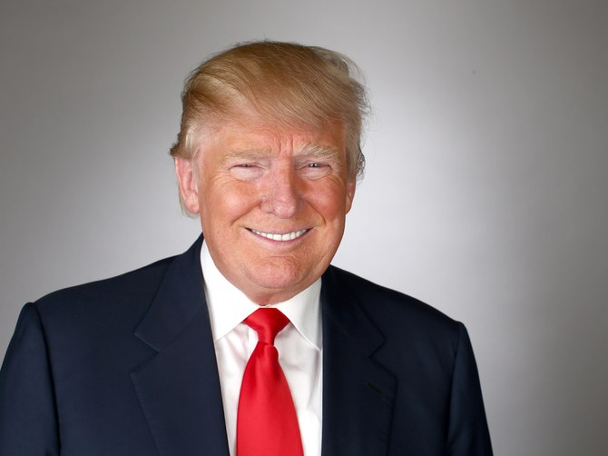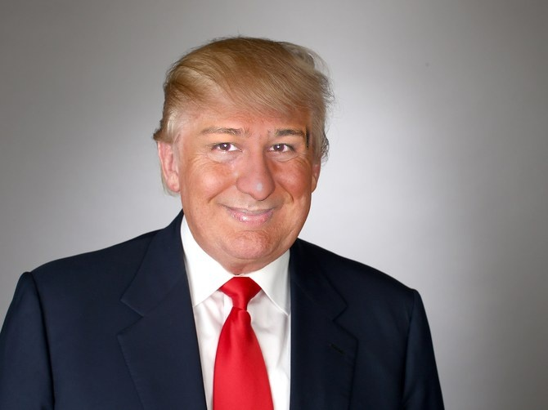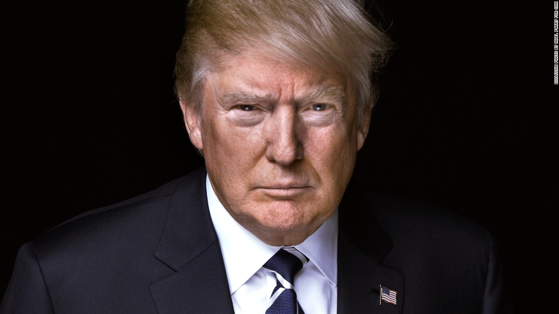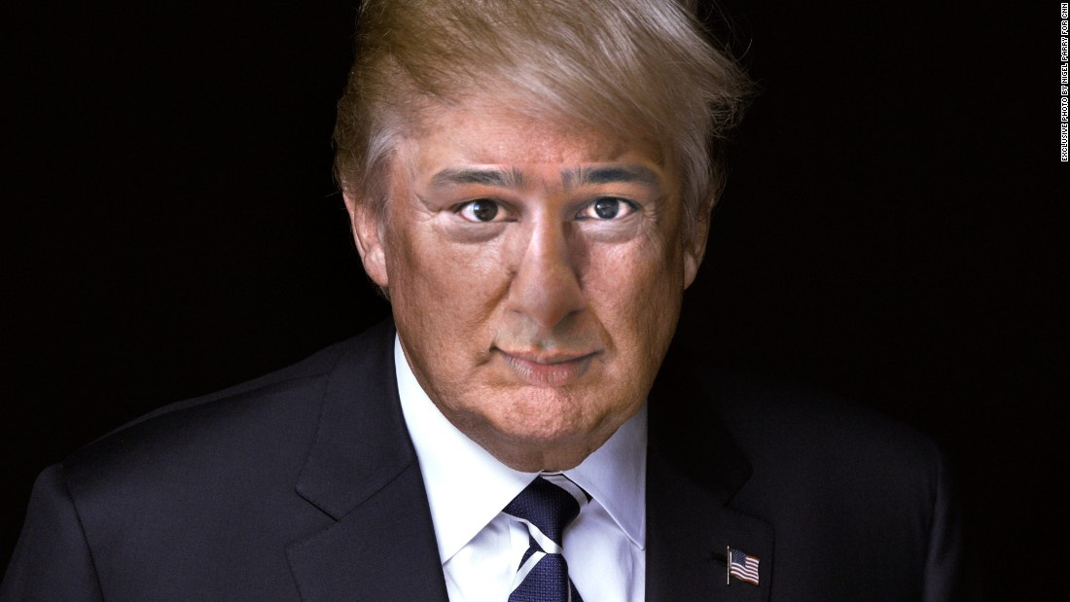

Caveats:

The typical face detection and segmentation algorithms extract a region smaller than desired. They tend to skip most of the forehead and ears. This is with good reason, since including forehead region has less landmarks and ears have background clutter. The figure below shows what face landmark detection typically picks up. You can notice the artifact it creates in the results above.

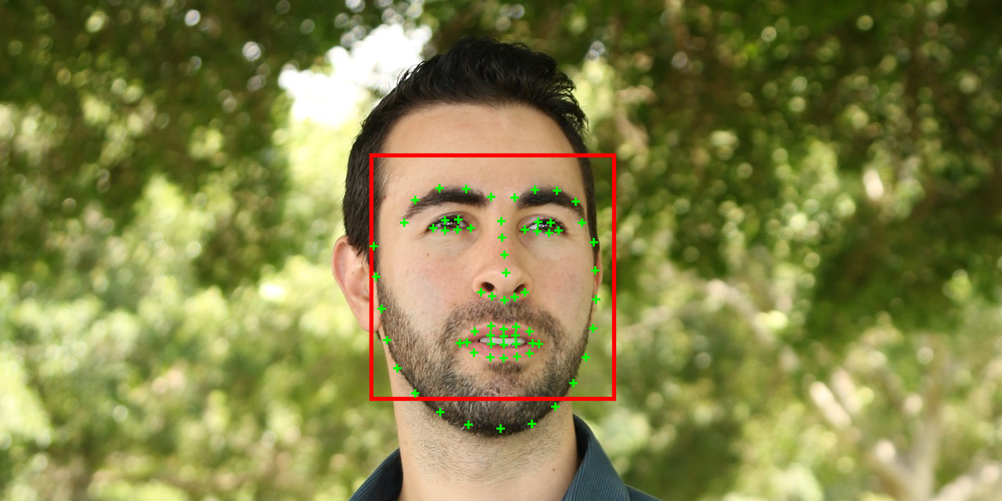

Yuval’s work on face segmentation looks promising and it is the immediate next item on my list. An important question regarding it is the manner in which GANs trained in entire face will deal with the segmented face region. The sample results from the author show radical variations in face image patch with the presence of occluding objects.

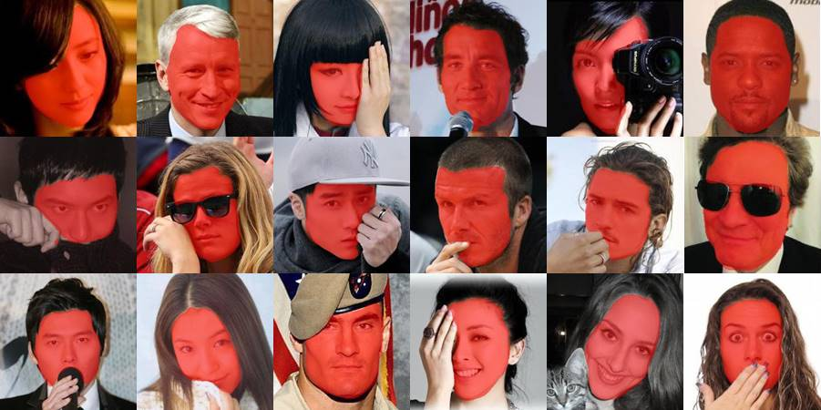

### GAN face swap

The use of GANs for face swap, among other things, allows for variation in pose between the donor and recipient face images. GANs require a lot of training data, so I scraped images from the internet to source training face images. My GAN is still training, a screen snapshot of one training routine is shown below. I am training the GAN to swap between images of Donald Trump and Angela Merkel.

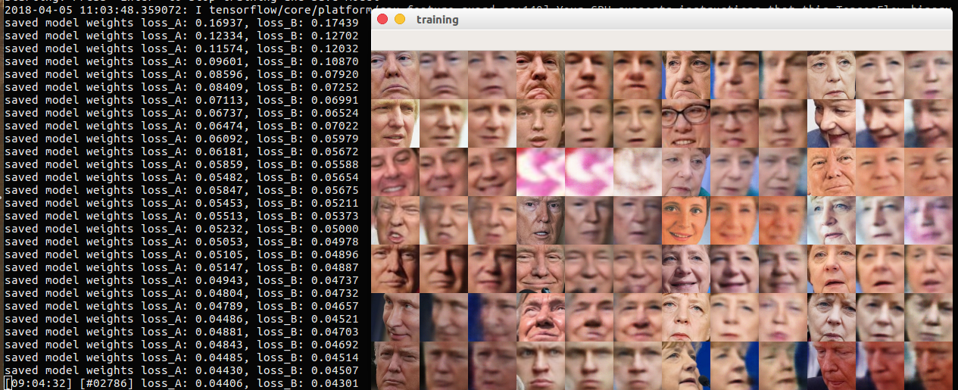

Once the loss on donor and recipient starts to look good, I’ll use the model checkpoint to swap between any two randomly acquired images of Trump and Merkel. Some caveats here are obvious.

1. I need to introduce a face recognition module to remove false positive faces from training images.

2. I might need to introduce some manner of stratified sampling based on face pose to help the GAN converge in a reasonable time. An obvious grouping here is between frontal and profile images, but I might need to introduce higher granularity here.

**Surrogate synthetic training sample generation**

Training GAN for celebrity images is relatively easy in terms of acquisition of training data, albeit with some data preprocessing. However, the question of training GAN for any random (non-celebrity) face is open. Perhaps, introducing synthetic warping and changes in illumination, color, etc. all together can create a training set from a single image for the GAN. I need to look into best practices here.

### Performance of variants of GAN architecture for CelebA dataset

The results show the snapshot result at around 30,000 iterations. We used 64x64 face size.

https://github.com/khanrc/tf.gans-comparison

We are borrowing ideas from researchers analyzing various GANs for performance in terms of inception score and in terms of convergence and stability.

Kodali, N., Abernethy, J., Hays, J., & Kira, Z. (2017). On Convergence and Stability of GANs. Retrieved from http://arxiv.org/abs/1705.07215

|  |  |
| --- | --- |
| DCGAN : Deep Convolutional GAN | EBGAN: Energy Based GAN |
|  |  |
| WGAN: Wasserstein GAN | BEGAN: Boundary Equilibrium GAN |
|  |  |
| DRAGAN: Deep Regret Analytic GAN | CoulombGAN |
|  |  |

### Progressive GAN

Karras, T., Aila, T., Laine, S., & Lehtinen, J. (2017). Progressive Growing of GANs for Improved Quality, Stability, and Variation, 1–26. <https://doi.org/10.1002/joe.20070>

Progressive GAN is great for generating photorealistic face images. I am wondering where in the pipeline should it be placed? Should it be used before or after face-swap?

Since the face-swap GAN is going to introduce its artifacts due to pose warping, it might make more sense to use progressive GAN as the final module to ameliorate artifacts and blemishes in the face image.

**Information-theoretic image contrast measure**

I finally found an annotated dataset of images for evaluating contrast enhancement called CEED2016.

<https://www.sciencedirect.com/science/article/pii/S0923596517301431?via%3Dihub>

I’ll be writing up our paper on it and get this pending publication out of the way.

**Learned local image patch descriptor**

A paper I am working on is evaluation of learned local patch descriptors for copy-move forgery detection. The descriptors are: AffNet; T-Feat; DELF; LIFT; HardNet; MatchNet and the hand-crafted descriptors for comparison with state-of-art in image forensic literation: SIFT, SURF, ORB.

I am concurrently working on introducing semantically relevant sparsity into the triplet based feature learning to create a novel and hopefully better learned descriptor. This will be another paper. The main contribution is that existing descriptors are trained purely on datasets with affine variation in images of the same object, whereas our paper will extend the use of learned descriptors to generic visual objects.

**GAN for image contrast enhancement**

Subsequent to submitting the papers for the work above and the required images to TA1 teams, I’d like to look into use of GANs for image contrast enhancement. The idea borrows from the triplet feature training paradigm. We extract patches (we can get millions of patches from a thousand images) from original and enhanced images in the CEED2016 dataset. Train the GAN with these and then use it to enhance any other image.